3. FLUID STATICS
PRESSURE: Intensity of applied force per unit area. Or intensity of compressive work per unit volume is pressure.
PRESSURE | STRESS
Always Compressive in nature | It may be tensile or maybe compressive or shear.
It’s scalar Quantity. | It’s Tensor Quantity.
Units: $1 bar={10}^{5} Pa,1 atm=1.01325 bar=10.3 mWater=760 mmHg$
PRESSURE IN TERMS OF HEAD OF FLUID: Height of a fluid column required to create a particular amount of pressure. E.g. $1 mmHg=133.33 Pa=1 tor$
STANDARD PRESSURES:
- ABSOLUTE ZERO: The pressure at which the molecular activity in matter completely stops.
- STANDARD ATMOSPHERIC: The pressure exerted by atmosphere at mean sea level on earth.
- LOCAL ATMOSPHERIC PRESSURE: the pressure exerted by atmosphere at particular location is local atmospheric pressure at that location. It’s non uniform reference.
ABSOLUTE SCALE: It’s measured w. r. t. absolute zero as reference. It’s always non negative.
GAUGE SCALE: it’s measured w. r. t. local atmospheric pressure as reference. It may be negative, 0 or positive.
PASCAL’S LAW: When constrained fluid is pressured, every point in the fluid experience a rise in pressure by same magnitude in all direction.  At equilibrium condition, $a_{x}=a_{y}=0⇒\sum{F_{x}}=\sum{F_{y}}=0$  $$P_{x}=P_{y}=P_{s}≠f(θ)$$  REST: $τ=0 \left(Constrained fluid\right)$  It’s valid for,  - Always valid for ideal fluid ($μ=τ=0$).  - Real Fluid:  Rest condition (${du}/{dy}=0$) Rigid Body motion ($a=Const.$) | 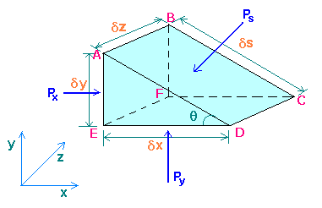
PASCAL’S MACHINE: Any machine which functions on principle of pascal’s law is known as pascal’s machine. E.g. Hydraulic lift. | $$Mec. Adv.=\frac{Load Lifted}{Force Applied}$$
Pressure at a point in a fluid at rest,
- Uniform intensity in all direction | - Compressive in nature | - Zero shear stress.

HYDROSTATIC LAW:  Aim: To identify the rate of change in pressure w. r. t. elevation for fluid at rest. | $$\frac{dP}{dz}=γ$$
Hydrostatic Law is valid for compressible and incompressible law.

HYDROSTATIC LAW FOR
INCOMPRESSIBLE FLUID | COMPRESSIBLE FLUID
$$∆P= γ∆h (Liner Variation)$$ | $$∆P=g\left[ρ_{0}h+\left({αh^{2}}/2\right)\right]\left\{∵ρ=ρ_{0}+αh\right\}(Parabolic Variation)$$

VARIATION OF PRESSURE IN ATMOSPHERE FOR
ISOTHERMAL CONDITION |  | VARIATION THERMAL CONDITION
$$\frac{dP}{dz}=-g\left(\frac{P}{RT}\right)$$ | $$P=P_{0}e^{\frac{g}{RT}\left(h_{0}-h\right)}$$ | $$\frac{dP}{dz}=\frac{-g}{R(T_{0}-αh)}$$ | $$P=P_{0}{\left(1-\frac{αz}{R_{0}}\right)}^{\frac{g}{Rα}}$$ | Where, $α=$ Lapse Rate,  Generally, $6≤α≤9K/{km}$  Std. Value $6.5 K/{km}$

Step1:  First Mark Reference.  Step 2:  Going down $$+P$$  Going up $$-P$$ | PIEZOMETER: $P_{abs}=P_{atm}+γh$  Limitations:  - Not suitable for gases fluids.  - Not suitable for high pressure measurement.  - Not suitable for vacuum or suction pressure. |  |  | 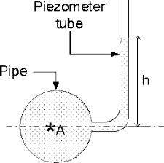
SIMPLE MANOMETER |  |  |  | 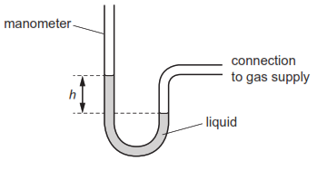
Advantages |  | Disadvantages
- Suitable for gas and slightly high pressure can be measure  - Vacuum Pressure can be measure. |  | - Very high pressure can’t measure.
DIFFERENTIAL MANOMETER |  |  | INVERTED DIFFERENTIAL/ “U” TUBE MANOMETER
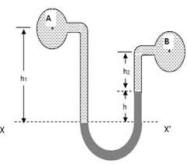 |  |  | 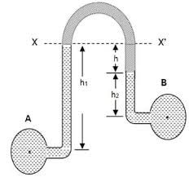
Aim: To measure difference in pressure between two point having relatively high pressure. |  |  | Aim: To measure relatively low pressure difference between two point.
$$∆P=h_{m}(γ_{m}-γ_{w})$$ |  |  | $$∆P=h_{m}\left(γ_{w}-γ_{m}\right)$$
$$h_{Water Col}=h_{m}\left(\frac{γ_{m}}{γ_{w}}-1\right)=h_{m}\left(\frac{S_{m}}{S_{w}}-1\right)$$ |  |  | $$h_{Water Col}=h_{m}\left(1-\frac{γ_{w}}{γ_{m}}\right)=h_{m}\left(1-\frac{S_{w}}{S_{m}}\right)$$
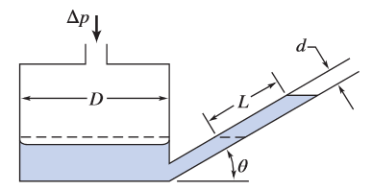 |  |  | INCLINED TUBE MANOMETER
Any manometer having at least one limb inclined w. r. t. the vertical plane. $L=h_{m}\sin{θ}$
Advantage: It increase sensitivity of pressure measurement.
Sensitivity: Ability of sense least amout of change.
$$Sensitivity=\frac{L}{h_{m}}=\frac{1}{\sin{θ}}$$
FORCES ON INCLINED SUBMERGED BODY IN THE FLUID:
$$h=x\sin{θ}$$ $$dF=PdA=γhdA=γ x\sin{θ} dA$$  $$dF=γ\sin{θ}x dA$$  $$\int{x dA}=\overline{x }A$$ $$\overline{x }\sin{θ}=\overline{h }$$  $$F=γ\overline{h }A=Avg. Pressure*Area$$  $$dM_{0}= γ\sin{θ}x^{2}dA$$  $$\int{x^{2} dA}=I_{YO}$$ $$I_{YO}=I_{YG}+A{\overline{x }}^{2}$$  $$M_{0}= γ\sin{θ}I_{YO}=γ\sin{θ}(I_{YG}+A{\overline{x }}^{2})$$  Here, $M_{0}=F*x^{*}=γ\overline{h }A x^{*}$  $$x^{*}=\frac{I_{YG}}{\overline{x }A}+\overline{x }$$ $$h^{*}=\frac{I_{YG}}{\overline{h }A}\sin^{2}{θ}+\overline{h }$$  $$e=x^{*}-\overline{x }=\frac{I_{YG}}{\overline{h }A}\sin{θ}$$ | 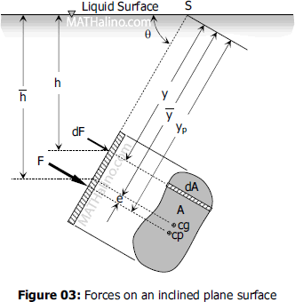

When $e=0$ (Centre of Pressure = Centre of Gravity),  - $\sin{θ}=0 ⇒$ Plate is in horizontal condition.  - $\overline{h }A≫I_{YG}\sin{θ}⇒$ Plate is considered at very high depth. | 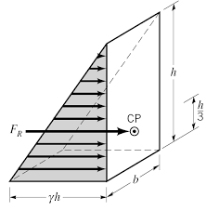
PRESSURE PRISM DIAGRAM:
- Volume of pressure prism indicates net force.
$$∀_{Pre. Prism}=F$$
- The projection of centroid of pressure prism on the surface of place represents centre of pressure.
Note: When area is not uniform to the page of plate avoid this method.

CURVED SURFACE |  |  | 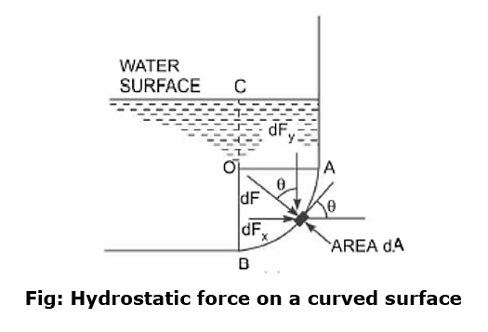
HORIZONTAL FORCE |  | VERTICAL FORCE
$$F_{H}=γ{\left(\overline{h }A\right)}_{Proj.}$$ |  | $$F_{V}=γ{\left(∀\right)}_{above}$$
$F_{H}$ is concentrated at the centre of pressure of projected area. |  | $F_{V}$ is weight equivalent thrust of the fluid above curved surface.
$$R=\sqrt{F_{H}^{2}+F_{V}^{2}}$$ | $$θ=\tan^{-1}\left(\frac{F_{V}}{F_{H}}\right)$$ | $${\left(h^{*}\right)}_{P}=\frac{I_{P}}{{\left(\overline{h }A\right)}_{P}}+{\overline{h }}_{P}$$
- Volume should be measured form the interface to the curved surface, regardless of the presence of fluid.
- $F_{V}$ passes through the centroid of the volume considered.
BUOYANCY: Upward force exerted by fluid on a completely or partially submerged object in the fluid is buoyancy.
ARCHIMEDES PRINCIPLE: “Buoyance force is equal to the weight of the fluid displaced.”
$$F_{B}=ρ∀g=γ∀$$ | $F_{B}$ passes through centroid of the volume of fluid displaced.

APPARENT WEIGHT |  | 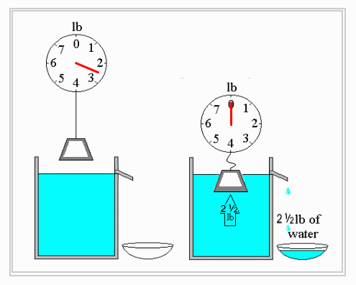
$$T=W-F_{B}$$ | $$\frac{T_{1}}{T_{2}}=\frac{W-F_{B1}}{W-F_{B1}}=\frac{γ-γ_{f1}}{γ-γ_{f2}}=\frac{S-S_{f1}}{S-S_{f2}}$$
EQUILIBRIUM AND STABILITY:
EQUILIBRIUM: Condition in which the net unbalanced force & net unbalanced moments equal to zero.
STABILITY: Ability of a body to restore initial equilibrium after disturbance.
TYPES OF EQUILIBRIUM BASED ON STABILITY
STABLE EQUILIBRIUM | UNSTABLE EQUILIBRIUM | NEUTRAL EQUILIBRIUM
It Gains original state | Further disturb itself | Finds new equilibrium state
E.g. $γ_{b}<γ_{f}\left(Floating body\right),$  $$γ_{b}=γ_{f}(Neutrally buoyant body)$$ | E.g. $γ_{b}>γ_{f}\left(Accelerating body\right)$
CONDITIONS REQUIRES FOR EQUILIBRIUM:
$$F_{B}=W_{body}$$ | $F_{B} \& W_{body}$ should have same line of action

STABILITY OF NEUTRALLY BUOYANT BODY
BOTTOM HEAVY BODY | TOP HEAVY BODY | HOMOGENOUS BODY
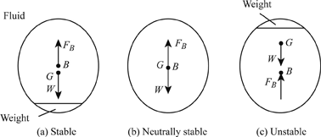 |  | 

STABILITY OF FLOATING BODY:  Here, $M=$Metacentre,  $BM=$ Metacentric Radius,  $GM=$ Metacentric Height.  If metacentric Height is positive equilibrium is stable equilibrium. B-G-M  $$GM=BM-BG$$  Stable & Neutral Unstable  $$BM≥BG$$ $$BM<BG$$ | 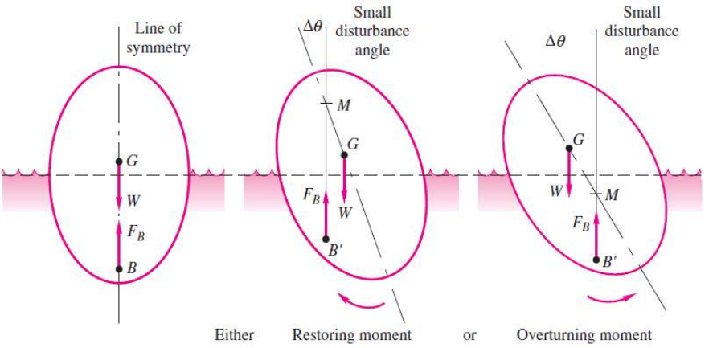
METACENTRE:
Point about which a floating body experiences simple harmonic oscillation when given small angle disturbs. $∆θ→0$
METACENTRIC RADIUS:
$$BM= \frac{I}{∀}$$  $I=$ AMOI of Top view in the waterline about rolling axis,  $∀=$ Volume of fluid displaced,  $$GM=BM-BG=\frac{I}{∀}-BG$$ | 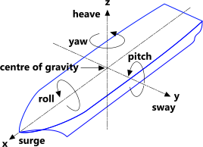
- Valid for only Simple harmonic Motion only & $∆θ→0$
- Metacentric Height Depends on geometry of ship, density of fluid and ship.
- Metacentric Height of particular body in a particular fluid is a constant.

TIME PERIODS OF ROLLING/ OSCILLATIONS:
$$Disturbing moment=(Mass MOI, I)(Acceleration, α)$$ | $$Restoring moment=W*GM\sin{θ}$$
$$Iα=W*GM\sin{θ}⇒m k^{2}α=mg GM θ⇒α=-\left({g GM}/{k^{2}}\right) θ⇒α=ω^{2}θ⇒α∝-Disp. (θ)⇒SHM$$
$$T=\frac{2π}{ω}=2π\sqrt{\frac{k^{2}}{g GM}}$$ | $$T∝ {GM}^{-1/2}⇒GM∝Stability$$  $${GM}_{War Ship}>{GM}_{Passanger Ship}$$

EXPERIMENT | $$GM=\frac{P x}{W\tan{θ}}(∵P≪W)$$ | $$GM=\frac{P x}{\left(W+P\right)\tan{θ}}$$ | $$Disturbing moment=Px\cos{θ}$$  $$Restoring moment=W*GM\sin{θ}$$

RIGID BODY MOTION
TRANSLATION | ROTATION
E.g. Below Mentioned Cases, etc… | E.g. Vortex Motion.
TRANSLATION RIGID BODY MOTION:
CASE-I: Vertical Translation
$$\sum{F_{z}}=ma_{z}$$ | $$F-W=ma_{z}⇒F=m\left(g+a_{z}\right)⇒F=mg_{eff}$$  $$Here, P={ρ∀g_{eff}}/A={ρAhg_{eff}}/A=ρg_{eff}h$$ | Vertical Translation in upward direction.
CASE-II: Vertical Translation
$$\sum{F_{x}}=ma_{x}$$ | $$F_{1}-F_{2}=γA_{1}\overline{h_{1}}-γA_{2}\overline{h_{2}}={\left[γ{\left(H+h\right)}^{2}1-γ{\left(H+h\right)}^{2}1\right]}/2$$  $$\& ma_{x}=ρBHa_{x}$$  $$∴θ=\tan^{-1}\left({a_{x}}/g\right)=\tan^{-1}\left({2h}/B\right)$$ | $$h=Height displaced$$  $$B=Width of container$$  $$H=Initial height of liq.$$
CASE-III: Translation Along Slope
$$θ=\tan^{-1}\left(\frac{a_{x}}{a_{z}+g}\right)$$ | $$a_{x}=a\cos{α} \& a_{z}=a\sin{α}$$  We can use same method like case II for derivation with $γ_{eff}$ | Vertical upward Translation on slope of $α$ angle

